سلام دوست عزیز! 😊

امیدوارم از این فایل استفاده مفیدی ببری. من مداوم فایل‌هام رو بروزرسانی می‌کنم و مطالب جدید اضافه می‌کنم، پس بهتره صفحه منو توی اینستاگرام دنبال کنی تا از آپدیت‌ها باخبر بشی. اونجا مطالب جدید و جالب به اشتراک می‌ذارم. منتظرت هستم!

ممنون که همراه منی! 🙌 🙏

 [@seyedmehdiarabi](https://www.instagram.com/seyedmehdiarabi/)

این پرامپت‌ها یک مجموعه هنری یکپارچه رو تشکیل میدن که در اون انواع غذاها به شیوه‌ای سورئال، صنعتی و مینیاتوری تصویرسازی شدن. هر پرامپت با ترکیب مفاهیم آشپزی سنتی با الهامات مکانیکی، ساخت‌وساز و علمی-تخیلی، فرآیند پخت‌وپز رو به یک صحنه پویا و فانتزی تبدیل میکنه.

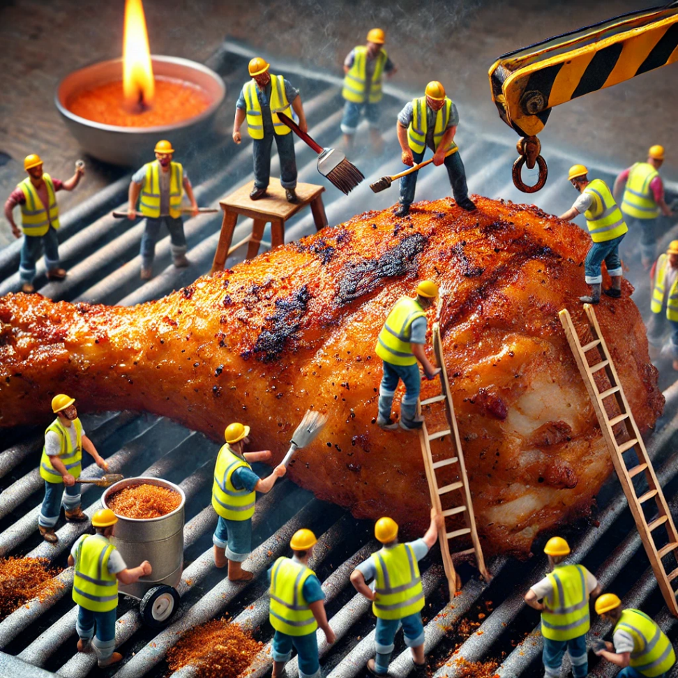

A gigantic, oversized chicken leg piece sizzling on a grill, surrounded by 1-inch-tall construction workers in neon vests and helmets. Some workers are using tiny paintbrushes to apply spicy marinade, while others operate a tiny crane to turn the chicken over. A worker with a welding torch creates a charred eﬀect on the edges, while another sprinkles masala from a mini spice shaker. Close-up shot, cinematic lighting, ultra-detailed textures.

Bread & Breakfast

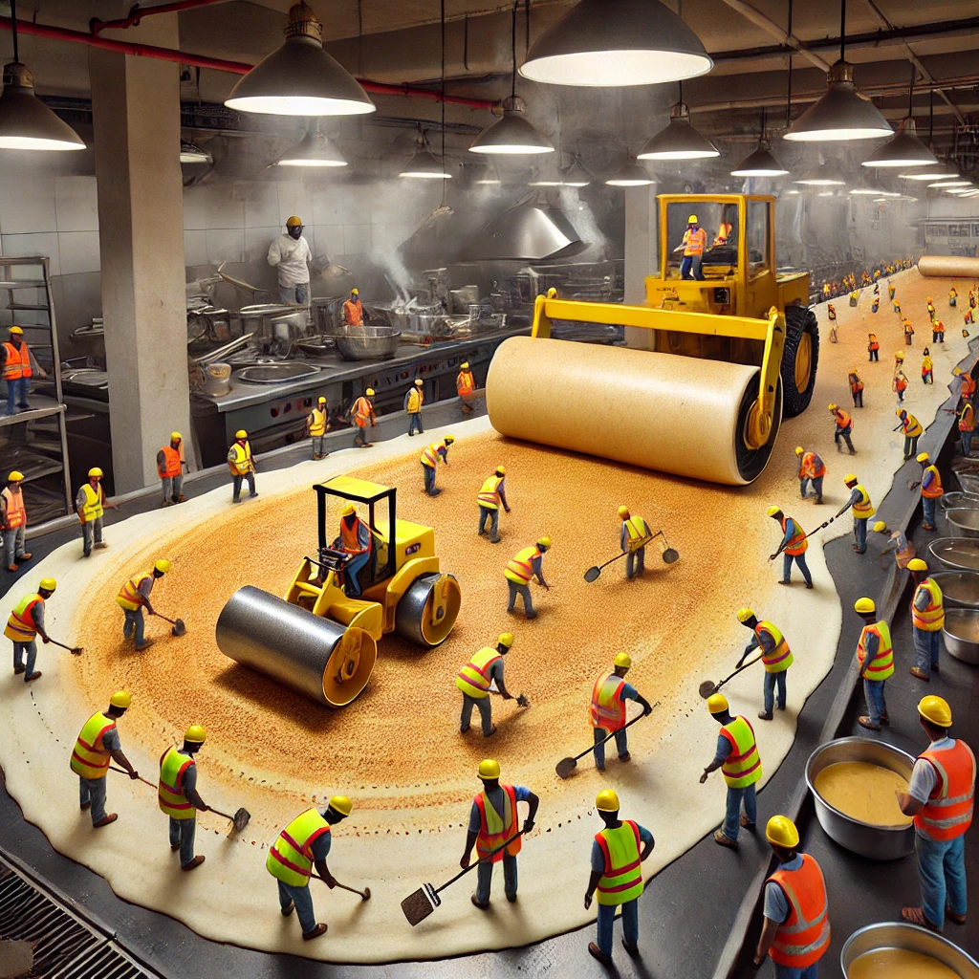

Dosa Highway Construction

A gigantic dosa, stretching like a newly paved highway, is sizzling on a tawa in a restaurant kitchen. Over 20 tiny construction workers (only 1 inch tall) in bright yellow safety vests and red helmets use mini steamrollers to smooth out the dosa batter, while others apply butter with oversized paintbrushes. A tiny crane lifts a scoop of potato masala into place before the dosa is folded. In the background, a chef flips another dosa while steam rises dramatically.

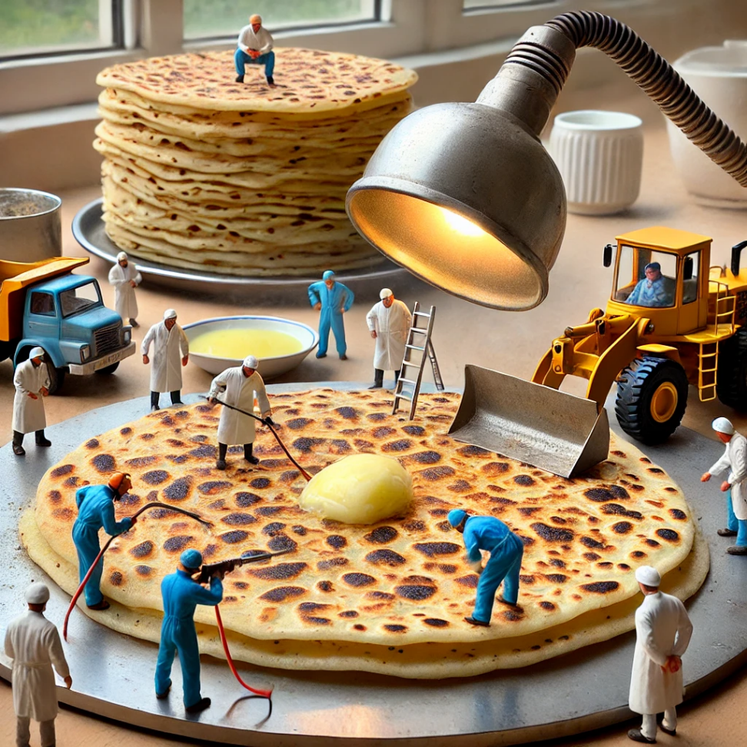

Paratha Welding Station

A giant paratha is on a hot tawa, being treated like a metal welding project. Miniature workers in heat-resistant suits use tiny blowtorches to melt butter across the crispy layers. A bulldozer pushes melted ghee evenly across the surface, while a quality inspector in a tiny lab coat checks the flakiness. In the background, a chef flips another paratha, while freshly made ones are stacked on a Plate.

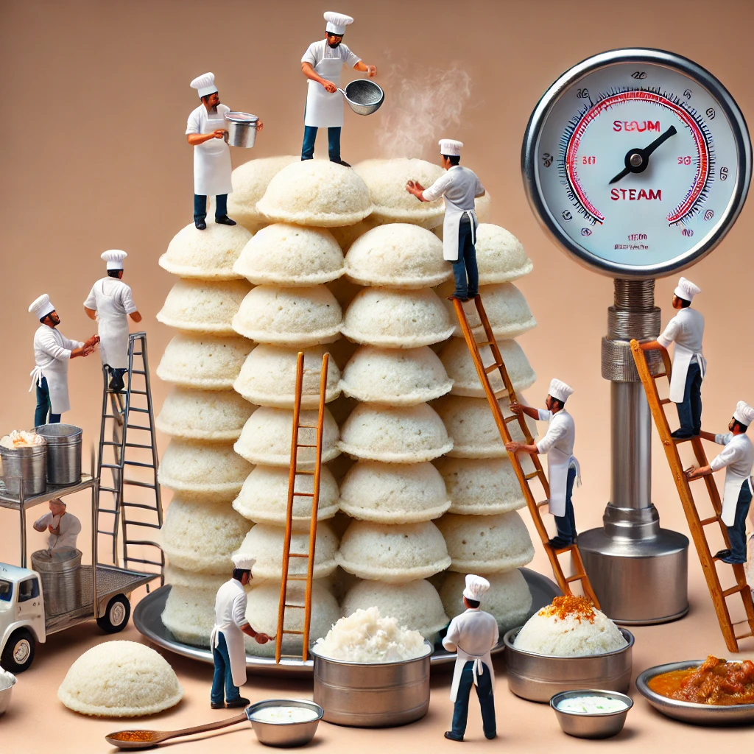

Idli Steaming Facility

A towering stack of soft, fluﬀy idlis is being carefully managed by tiny chefs (1 inch tall) in white aprons and hats. Some workers are using mini ladders to climb up and sprinkle chutney powder, while others transport coconut chutney in tiny buckets. A steam gauge operator monitors the perfect texture of the idlis. In the background, a chef plates steaming hot idlis with sambar and chutney.

4. Puri Inflation Plant

A large kadhai filled with bubbling hot oil is transformed into a balloon-inflating station for crispy golden puris. Tiny workers (1 inch tall) in orange jumpsuits use mini air pumps to ensure each puri puﬀs up perfectly. A crane carefully lifts a puﬀed puri, while a quality control team uses tiny measuring tapes to check its roundness. In the background, a chef drains freshly fried puris onto a plate, ready to be served with chole.

5. Pav Bhaji Construction Zone

A massive, steaming pile of bhaji on a hot tawa resembles a demolition site. Miniature bulldozers mash the vegetable mixture, while workers use paint rollers to spread butter on pav buns. A tiny crane lifts a cube of butter, melting instantly into the bhaji. In the background, a chef flips another batch, and tiny workers are seen carrying buckets of chopped onions and coriander.

Rice Dishes & Biryani

6. Chicken Biryani Excavation Site

A giant handi of steaming chicken biryani is being excavated like a construction dig site. Tiny workers (1 inch tall) in yellow helmets use mini shovels to uncover layers of saﬀron-infused rice, while a crane lifts a whole, spice-coated chicken leg from the depths. A tiny excavator sprinkles crispy fried onions as garnish. In the background, a chef carefully plates the biryani, with a side of raita and lemon wedges.

7. Pulao Plantation

A huge plate of fragrant vegetable pulao is transformed into a tiny farm, where miniature farmers (1 inch tall) plant diced carrots and peas like crops. Tiny watering cans pour saﬀron-infused liquid over the rice, while a tiny harvester gathers perfectly cooked grains. In the background, a chef garnishes the dish with roasted cashews and raisins.

8. Curd Rice Glacier

A chilled, creamy bowl of curd rice looks like a snow-covered mountain. Tiny climbers in winter gear are scaling the surface, using mini ice picks to carve paths. A crane pours a stream of fresh curd, while another worker sprinkles pomegranate seeds like jewels. In the background, a chef stirs the curd rice, preparing it for plating.

9. Tomato Rice Painting Project

A large plate of spicy tomato rice is treated like a massive painting project. Tiny workers (1 inch tall) use paint rollers to spread the tomato masala, while another lifts a giant tomato slice with a crane. Some workers sprinkle coriander leaves from tiny sacks, ensuring perfect presentation. In the background, a chef scoops a fresh serving onto another plate, steam rising gently.

10. Khichdi Cement Mixing Zone

A giant pot of steaming khichdi is transformed into a cement mixing plant, where tiny workers operate rotating drums to mix lentils and rice. A mini crane pours melted ghee, while another worker sprinkles cumin seeds from a tiny container. On the ground, miniature shovels mix in soft vegetables. In the background, a chef serves the creamy khichdi with a side of papad and mango pickle.

Street Foods

11. Pani Puri Water Treatment Plant

A large serving tray of crispy pani puris is turned into a water treatment facility, where tiny workers (1 inch tall) in blue uniforms operate miniature pipes to pour spicy and sweet water into each puri. Some workers fill puris with tamarind chutney using tiny syringes, while a crane gently places mashed potato stuﬃng inside each puri. In the background, a chef refills a bowl with more Puris.

12. Vada Pav Fast Food Factory

A vada pav assembly line in a restaurant kitchen is fully automated, where tiny workers in fast-food uniforms oversee each step. Some workers operate a mini deep fryer to crisp up the vadas, while others use a conveyor belt to move soft pav buns through a buttering station. A tiny crane spreads garlic chutney before placing the vada inside. In the background, a chef arranges freshly made vada pavs with fried green chilies on the side.

13. Samosa Construction Site

A gigantic samosa is being assembled like a pyramid construction project. Tiny workers (1 inch tall) in orange safety vests climb mini ladders to seal the crispy edges using a dough-sealing machine. A tiny crane lowers a scoop of spicy potato filling into the triangular shell, while another team brushes the surface with ghee using paintbrushes. In the background, a chef carefully lowers another samosa into a bubbling kadhai of oil.

Fried & Grilled Foods

14. Bajji Deep-Frying Assembly Line

A massive kadhai filled with hot oil is transformed into a miniature deep-frying plant, where tiny workers (1 inch tall) in aprons and chef hats dip sliced banana, mirchi, and potato into spicy batter using mini ladles. A tiny crane carefully lowers a batch of bajjis into the oil, while another team uses fans to cool the freshly fried bajjis before plating. In the background, a chef arranges crispy bajjis on a banana leaf with coconut chutney.

15. Chicken Leg Piece BBQ Pit

A huge grill loaded with marinated chicken leg pieces resembles a construction zone, where tiny workers in heat-resistant suits use miniature blowtorches to char the edges perfectly. A tiny crane drizzles melted butter, while another worker uses a spice shaker to dust the meat with masala. A worker with a meat thermometer checks the internal temperature. In the background, a chef flips another chicken piece, smoke rising dramatically.

16. Tandoori Chicken Kiln

A traditional clay tandoor glows red-hot as tiny chefs (1 inch tall) in aprons and safety goggles rotate massive tandoori chicken skewers inside. A crane carefully lowers a skewer into the tandoor, while another worker uses a giant brush to baste butter over the sizzling meat. In the background, a chef removes a perfectly grilled tandoori chicken, plating it with onion rings and mint chutney.

17. Chicken 65 Frying Factory

A deep fryer bubbling with oil is transformed into a high-tech frying station, where tiny workers use miniature frying baskets to submerge battered chicken pieces. A conveyor belt transports crispy Chicken 65 pieces to a spice-coating station, where workers in red aprons sprinkle curry leaves and green chilies from tiny baskets. In the background, a chef stirs another batch in a wok, ensuring even coating.

18. Chicken Lollipop Assembly Line

A steel kitchen countertop is a miniature food production line, where tiny workers in chef hats shape chicken drumettes into perfect lollipops. A robotic arm dips them into spicy batter, while another rotates them in hot oil. A tiny crane lifts a freshly fried lollipop, and a worker brushes schezwan sauce for extra flavor. In the background, a chef arranges lollipops on a plate with dipping sauce.

19. Seekh Kebab Skewer Factory

"A long charcoal grill stretches across a restaurant kitchen, where tiny workers (1 inch tall) in white chef coats mold spiced minced chicken onto skewers. A rotating mechanism ensures even grilling, while a tiny spice sprinkler dusts them with garam masala. A tiny crane lifts a sizzling kebab onto aserving plate, while workers add fresh lemon slices and mint chutney. In the background, a chef checks another batch for perfect char.

20. Chettinad Chicken Spice Lab

A massive wok filled with fiery Chettinad chicken resembles a scientific experiment. Tiny workers in lab coats and goggles carefully pour coconut milk from tiny beakers, balancing the heat. Another sprinkles black pepper and roasted curry leaves using precision spice droppers. A tiny crane lifts a whole drumstick, ensuring the masala coats evenly. In the background, a chef stirs another batch, adjusting spice levels.

Sweets & Desserts

21. Jalebi Factory Pipeline

A large wok of sizzling hot oil serves as a jalebi production plant, where tiny workers in orange aprons operate a mini piping system to shape perfect jalebi spirals. A crane dips freshly fried jalebis into a sugar syrup reservoir, while another worker dusts them with saﬀron and pistachios. In the background, a chef arranges the crispy, golden jalebis onto a serving tray.

22. Gulab Jamun Oil Rig

"A floating oil rig setup is frying massive gulab jamuns, where tiny workers in safety vests carefully lower deep-fried dough balls into a huge sugar syrup vat. A crane lifts a perfectly soaked gulab jamun, dripping with syrup, while another worker sprinkles chopped nuts. In the background, a chef inspects a fresh batch for softness.

23. Kaju Katli Diamond Cutting Unit

A giant slab of kaju katli sits on a marble countertop, where tiny workers with precision saws cut it into perfect diamond shapes. A mini crane carefully places edible silver foil on top, while a quality control team measures thickness with calipers. In the background, a chef arranges freshly cut kaju katli pieces into a decorative box. Beverages

24. Chai Brewing Power Plant

A giant brass kettle bubbles with steaming hot masala chai, where tiny tea makers in aprons operate miniature spice dispensers to add cardamom, ginger, and cinnamon. A tiny crane pours foamy milk into the kettle, while another worker monitors the boiling level with a thermometer. In the background, a chef pours chai into clay cups, creating a frothy top.

25. Filter Coﬀee Dabara Station

A tall steel tumbler holds frothy South Indian filter coﬀee, where tiny workers in dhotis and aprons carefully pour the decoction into mini brass filters. A tiny crane lifts a steaming dabara, ensuring the perfect froth height. Another worker sprinkles sugar from a miniature container. In the background, a chef pours coﬀee from a height for dramatic eﬀect."Special Food Setups

26. Thali Platter Coordination Center

A massive Indian thali is arranged like an airport runway, where tiny workers in chef uniforms carefully position bowls of dal, sabzi, and raita in perfect alignment. A mini crane lowers a chapati into the center, while another worker adjusts the placement of papad for crunchiness. In the background, a chef does a final garnish check before serving.

27. Biryani Dum Cooking Chamber

A sealed handi of biryani is treated like a high-security vault, where tiny workers with safety gear reinforce the dough-sealed lid, ensuring no steam escapes. A crane carefully lifts a piece of saﬀron- infused rice, inspecting its aroma. In the background, a chef prepares to break the seal, revealing fragrant steam.

28. Mango Pickle Aging Warehouse

A giant ceramic jar filled with spicy mango pickle resembles a wine cellar, where tiny workers with tiny spice scoops test the aging process. A tiny forklift carries freshly chopped mango pieces, while another worker stirs the masala with a wooden stick. In the background, a chef seals the jar for long-term fermentation.

Street Foods

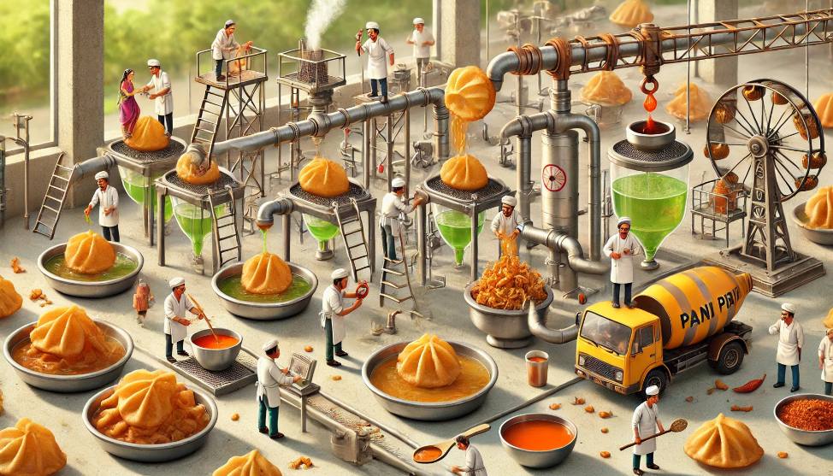

Pani Puri Water Treatment Plant

A large stainless-steel tray holds a row of crispy pani puris, each being meticulously filled by tiny workers managing a high-tech pipeline system. Some workers are adjusting the flow of spicy and sweet water, ensuring perfect proportions, while others use precision nozzles to add tamarind chutney. A crane lifts a freshly prepared puri onto a serving plate, while a quality control team inspects each puri for structural integrity. In the background, a chef refills a bowl with more puris, steam rising from a pot of freshly boiled potatoes.

Vada Pav Factory

A long assembly line in a restaurant kitchen is dedicated to producing the perfect vada pav. Tiny workers stand at diﬀerent stations, one carefully frying golden-brown batata vadas, another using a spatula to slice soft pav buns open, and another using a paint roller to spread garlic chutney evenly. A conveyor belt moves the assembled vada pavs toward a plating section where workers garnish them with fried chilies. In the background, a

chef stacks a fresh batch onto a tray, while steam from hot vadas rises into the air.

36. Dabeli Railway Station

A dabeli stall is transformed into a busy railway station, where miniature workers load sweet and spicy peanut filling into freshly toasted buns. Some workers are operating tiny spice sprayers to evenly distribute the special masala, while others arrange pomegranate seeds and sev toppings with tweezers. A crane lifts a perfectly prepared dabeli onto a serving plate, where another team is drizzling tamarind chutney. In the background, a chef prepares more dabelis, stacking them neatly on a wooden board.

37. Samosa Construction Site

A single oversized samosa sits on a steel tray, being assembled like a monumental architectural project. Miniature workers in safety gear are carefully sealing the crispy edges using tiny pastry brushes dipped in flour paste. A crane is lowering a scoop of spicy potato filling into the open shell before it gets sealed shut. Workers climb scaﬀolding to add a final coating of oil for the perfect golden-brown texture. In thebackground, a chef drops another samosa into a bubbling kadhai of oil, with crispy layers forming instantly.

38. Kachori Volcano

A massive kachori sits on a serving plate, resembling a dormant volcano about to erupt. Tiny workers climb ladders to crack open the crispy shell, revealing a steaming, spicy lentil filling. Some workers use tiny buckets to pour tamarind and mint chutney, creating a lava-like eﬀect. A bulldozer pushes sev and chopped onions to the edges for garnishing. In the background, a chef arranges more kachoris, preparing them for serving.

Rice Dishes

39. Tomato Rice Painting Project

A plate of spicy tomato rice is being treated like an artistic masterpiece, with miniature workers using paint rollers to evenly spread the red masala over the rice. A worker carefully places curry leaves like decorative elements, while another sprinkles roasted peanuts like golden embellishments. A small crane lifts a giant tomato slice onto the center, ensuring the perfect presentation. In the background, a chef scoops a fresh

serving onto another plate, steam rising gently.

40. Khichdi Construction Zone

A steaming pot of khichdi is treated like a cement mixing plant, where tiny workers operate a rotating drum to ensure the lentils and rice are perfectly blended. A crane carefully pours melted ghee onto the dish, while another worker sprinkles cumin seeds and coriander leaves from a spice shaker. Workers on the ground use tiny shovels to mix in soft vegetables for added texture. In the background, a chef stirs another batch of khichdi with a large ladle, preparing it for serving.

Fried & Grilled Items

41. Bajji Deep-Frying Assembly Line

A large kadhai filled with bubbling oil hosts a high-tech bajji-making factory. Miniature workers dip sliced banana, mirchi, and potato into thick chickpea batter before lowering them into the oil using pulley systems. A tiny crane lifts a freshly fried bajji onto a cooling rack, while another worker dusts it with chaat masala. In the background, a chef arranges hot bajjis on a banana leaf, alongside coconut chutney and a cup of steaming chai.

42. Chicken Leg Piece BBQ Pit

A large grill is transformed into a fiery barbecue pit, where miniature workers are carefully basting massive chicken leg pieces with spicy marinade. Some workers use tiny blowtorches to achieve the perfect char, while others rotate skewers to ensure even cooking. A crane drizzles melted butter from a tiny container, while a worker inspects the grill marks with a magnifying glass. In the background, a chef flips another batch of tandoori chicken, smoke rising into the air.

Beverages

43. Badam Milk Bottling Unit

A giant steel pot filled with hot, saﬀron-infused badam milk sits in a bustling kitchen, where tiny workers grind almonds into a smooth paste using a mini milling machine. A crane carefully pours a golden stream of milk into decorative glasses, while another worker sprinkles chopped pistachios and saﬀron strands. A cooling teamensures the perfect serving temperature before bottling. In the background, a chef stirs another batch, ensuring the milk is rich and creamy.

44. Falooda Layering Station

A tall glass of falooda is being built like a skyscraper, with tiny workers carefully layering rose syrup, basil seeds, and falooda noodles. A crane places a scoop of vanilla ice cream on top, while a worker uses a tiny spoon to drizzle extra syrup. A sugar specialist sprinkles chopped nuts in perfect symmetry. In the background, a chef prepares another glass, ensuring every layer is flawless.

45. Sharbat Cooling Station

A massive glass of rose sharbat is set up like a cooling plant, where miniature workers operate ice dispensers to maintain the perfect chill. A pipeline system pumps fresh rose syrup into the glass, while another team stirs in sabja seeds. A crane delicately places fresh mint leaves on the surface. In the background, a chef pours another round of cold sharbat for customers.

Special Food Setups

46. Mango Pickle Aging Warehouse

A giant ceramic jar of mango pickle is stored in a spice- aging facility, where workers check the absorption of masala and oil. Some workers climb ladders to stir the mixture, ensuring even distribution of flavors. A tiny forklift carries freshly cut mango pieces into the jar, while another worker seals it for aging. In the background, a chef inspects another jar, ensuring it is perfectly preserved.

47. Thali Platter Coordination Center

A traditional Indian thali is arranged like an airport runway, where miniature workers carefully position bowls of dal, sabzi, raita, and desserts in a symmetrical pattern. A crane places a soft chapati in the center, while a worker adjusts the papad for the perfect crunch. Another worker sprinkles coriander garnish in a precise motion. In the background, a chef makes final adjustments before serving.

48. Biryani Dum Cooking Chamber

A sealed handi of biryani is treated like a high-security vault, where workers monitor the slow-cooking process. Some workers reinforce the dough- sealed lid, ensuring no steam escapes, while another team checks the temperature for even cooking. A crane lifts a saﬀron-infused rice grain for quality inspection. In the background, a chef prepares to break the seal, releasing a cloud of fragrant steam.

Final Touches

49. Sugarcane Juice Factory

A sugarcane juice extraction unit is in full operation, where miniature workers feed sugarcane stalks into a roller press. Some workers control the flow of fresh juice into tall glasses, while another team adds lemon and ginger extracts. A quality control worker checks the foam level before serving. In the background, a chef pours another round of juice for customers.

50. Masala Soda Carbonation Unit

A soda bottling plant is operating at full capacity, where miniature workers infuse fresh masala and lime juice into glasses. A carbonation machine fizzes up the drink, while another worker carefully places mint leaves for garnish. In the background, a chef stirs a freshly made masala soda with a straw, ready to serve.